Lab 9
BGP
Objective:
The purpose of this lab is for the student to understand, create and implement BGP. Students will also utilize IOS commands to explore and configure BGP on network routers and switches.
Diagram:
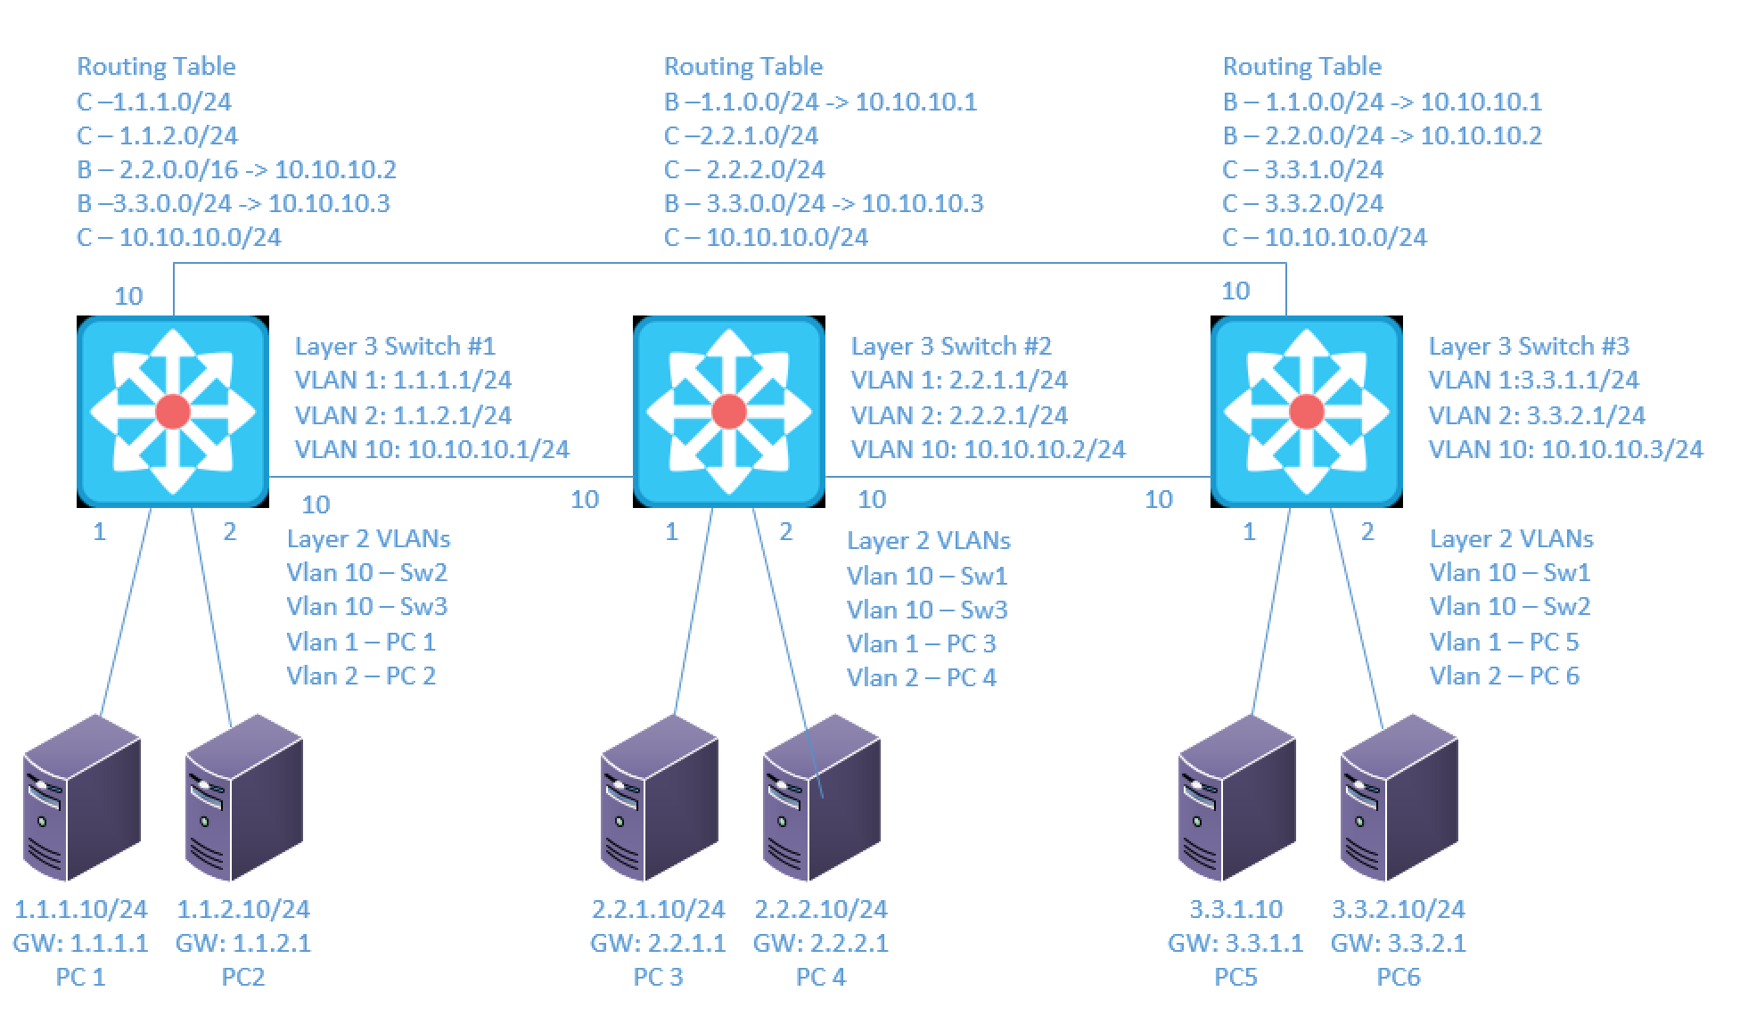
Components:
6 – PCs with an Ethernet NIC
3 – Cisco 3650 Layer 3 Switches

Useful commands for this lab:
show ip route – view routing table
show ip interface brief - view brief list of interfaces
show vlan – view vlan database
show ip bgp neighbors – View Established BGP neighbors
show ip bgp summary – view summary of BGP info

Configure BGP basic options

router bgp 1
network 1.1.1.0 255.255.255.0 !advertise 1.1.1.0/24 into BGP
network 1.1.2.0 255.255.255.0 !advertise 1.1.2.0/24 into BGP
bgp router-id 10.10.10.1 ! sets router-id to 10.10.10.1

Configure BGP neighbor options

router bgp 1
neighbor 10.10.10.2 remote-as 2 !configure neighbor with AS of 2
neighbor 10.10.10.2 password Netcom !configure neighbor w/ pw
neighbor 10.10.10.3 remote-as 3 !configure neighbor with AS of 3
neighbor 10.10.10.3 password Netcom !configure neighbor w/ pw

Configure BGP route summarization

DO NOT DO BOTH. CHOOSE FIRST OR SECOND OPTION

router bgp 1
aggregate-address 1.1.0.0 255.255.0.0 summary only

or

router bgp 1
network 1.1.0.0 mask 255.255.0.0
exit
ip route 1.1.0.0 255.255.0.0 null0
! Configures route for 1.1.0.0/16 in the local routing table to Null0. Also, must remove 1.1.1.0/24 and 1.1.2.0/24 network commands from BGP to use this option.

Procedure:
- Connect all PC’s together and put their static IP addresses, subnet masks and gateways on them. Test connectivity by pinging each machine within the network.

- Use the diagram above to label the Layer 3 switches VLAN IP addresses below

Layer 3 Switch (1) |  | Layer 3 Switch (2) |  | Layer 3 Switch (3)
VLAN | IP | VLAN | IP | VLAN | IP
1 | 1.1.1.1/24 | 1 | 2.2.1.1/24 | 1 | 3.3.1.1/24
2 | 1.1.2.1/24 | 2 | 2.2.2.1/24 | 2 | 3.3.2.1/24
10 | 10..10.10.1/24 | 10 | 10.10.10.2/24 | 10 | 10.10.10.3/24

- Use the diagram above to label the routing tables for the Layer 3 switch and routers below.
Layer 3 Switch (1) | Layer 3 Switch (2) | Layer 3 Switch (3)
B-1.1.0.0/16->10.10.10.1 | B-1.1.0.0/16->10.10.10.1 | B-1.1.0.0/16->10.10.10.1
C-2.2.1.0/24 | C-2.2.1.0/24 | B-2.2.0.0/16->10.10.10.2
C-2.2.2.0/24 | C-2.2.2.0/24 | C-3.3.1.0/24
B-3.3.0.0/16->10.10.10.3 | B-3.3.0.0/16->10.10.10.3 | C-3.3.2.0/24
C-10.10.10.0/24 | C-10.10.10.0/24 | C-10.10.10.0/24

- Use the diagram above to label the switches ports and what vlans they are in below.

Layer 3 Switch (1) | Layer 3 Switch (2) | Layer 3 Switch (3)
Fa0/1 - Vlan 1 | Fa0/1 - Vlan 1 | Fa0/1 - Vlan 1
Fa0/2 - Vlan 2 | Fa0/2 - Vlan 2 | Fa0/2 - Vlan 2
Fa0/23 - Vlan 10 | Fa0/23 - Vlan 10 | Fa0/23 - Vlan 10
Fa0/24 - Vlan 10 | Fa0/24 - Vlan 10 | Fa0/24 - Vlan 10

- Place the switch ports into the proper vlans. Configure all of the switches vlan IP addresses.

- Enable routing on the Layer 3 switches

- On switch 1 enable router BGP as follows:
  - Make the ASN number 1
    - What command did you enter
Router bgp 1
  - Add neighbor 10.10.10.2 with ASN of 2
    - What command did you enter
Neighbor 10.10.10.2 remote-as 2
  - Add neighbor 10.10.10.3 with ASN of 3
    - What command did you enter
Neighbor 10.10.10.3 remote-as 3
  - Add the connected networks except 10.10.10.0/24 to BGP. With BGP we don’t have to add the 10.X network since BGP uses the neighbor commands to decide where to send updates. All L3 switches already have the 10 network so we don’t have to tell them about each other.
    - What commands did you enter
Network 1.1.1.0 mask 255.255.255.0
Network 1.1.2.0 mask 255.255.255.0
- On switch 2 enable router BGP as follows:
  - Make the ASN number 2
    - What command did you enter
Router bgp 2
  - Add neighbor 10.10.10.1 with ASN of 1
    - What command did you enter
Neighbor 10.10.10.1 remote-as 1
  - Add neighbor 10.10.10.3 with ASN of 3
    - What command did you enter
Neighbor10.10.10.3 remote-as 3
  - Add the connected networks except 10.10.10.0/24 to BGP
    - What commands did you enter
Network 2.2.1.0 mask 255.255.255.0
Network 2.2.2.0 mask 255.255.255.0
- On switch 3 enable router BGP as follows:
  - Make the ASN number 3
    - What command did you enter
Router bgp 3
  - Add neighbor 10.10.10.2 with ASN of 2
    - What command did you enter
Neighbor 10.10.10.2 remote-as 2
  - Add neighbor 10.10.10.1 with ASN of 1
    - What command did you enter
Neighbor 10.10.10.1 remote-as 1
  - Add the connected networks except 10.10.10.0/24 to BGP
    - What commands did you enter
Network 3.3.1.0 mask 255.255.255.0
Network 3.3.2.0 mask 255.255.255.0
- Verify the routing table on the Layer 3 switches
- Can the computers ping each other? Yes
  - Why? BGP is configured on all switches and each routing table has paths to the other networks
- View the BGP neighbor table on switch 1
  - What command did you enter? show ip bgp neighbor
  - How many neighbors are listed? 2
- View the routing table on switch 1
  - What command did you enter? show ip route
  - How many routes are listed for 2.X.X.X networks? 2 routes
  - How many routes are listed for 3.X.X.X networks? 2 routes
- On switch 1 add neighbor authentication to each neighbor with a password of netcom
  - What commands did you enter?
Neighbor 10.10.10.2 password netcom
neighbor 10.10.10.3 password netcom
  - What happened to Switches 1 BGP neighbors? They went down
  - Why? They are not configured with a matching password
- On switch 2 and switch 3 add neighbor authentication to each neighbor with a password of netcom

- On switch 1 remove the advertised networks
  - What commands did you enter
No network 1.1.1.0 mask 255.255.255.0
No network 1.1.2.0 mask 255.255.255.0
- On switch 1 add a route summary for 1.1.0.0/16
  - What command did you enter?
Network 1.1.0.0 mask 255.255.0.0
- View the routing tables on switch 2 and 3 for the 1.1.X.0 networks
  - How many are there? 0
  - Did the table change? Yes
  - Why? BGP does not advertise networks that aren’t in the table
- On switch 1 add a static route for 1.1.0.0/16 to interface null0
  - What command did you enter?
Ip route 1.1.0.0 255.255.0.0 null0
- View the routing tables on switch 2 and 3 for the 1.1.X.0 networks
  - How many are there? 1
  - Did the table change? Yes
  - Why? A static route was added
- On switch 2 add a route summary for 2.2.0.0/16
  - What command did you enter?
Network 2.2.0.0 mask 255.255.0.0
- On switch 2 add a static route for 2.2.0.0/16 to interface null0
  - What command did you enter?
Ip route 2.2.0.0 255.255.0.0 null0
- On switch 3 add a route summary for 3.3.0.0/16
  - What command did you enter?
Network 3.3.0.0 mask 255.255.0.0
- On switch 3 add a static route for 3.3.0.0/16 to interface null0
  - What command did you enter?
Ip route 3.3.0.0 255.255.255.0 null0
- View the routing tables on all the switches
  - How many are there? 1 for each network set
  - Did the tables change? Yes
  - Why? Summarized routes were added
  - Does this feature work like OSPF and EIGRP? Yes
- Draw the lab diagram below (PC’s, router and switch connections) Label the IP addresses, subnet masks, and gateways used by each device. Label the routing tables next to the switch and router and the switches vlan IP addresses and port vlan information.

